**ACTIVITY 1**

* **Dataset Table data (columns should be visible) with the applied steps box visible**

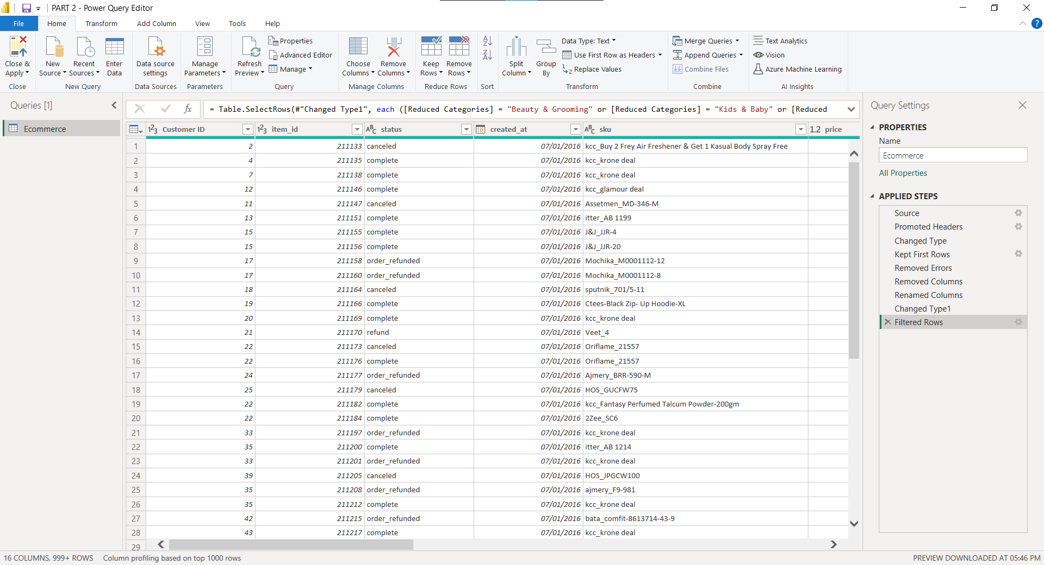

* **Calendar Table data (columns should be visible) with the applied steps box visible**

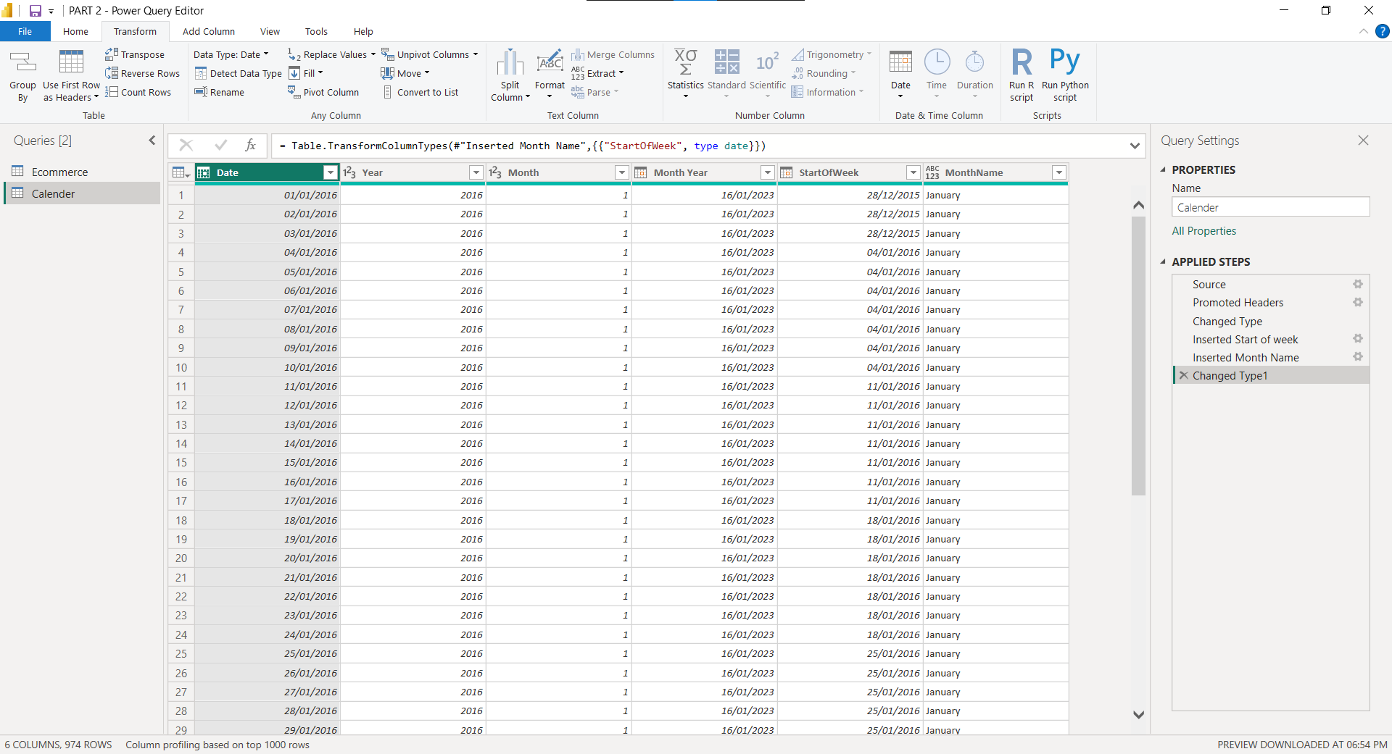

* **The relationship connection made between the two tables (must show one to many relationship and direction must be from calendar to dataset)**

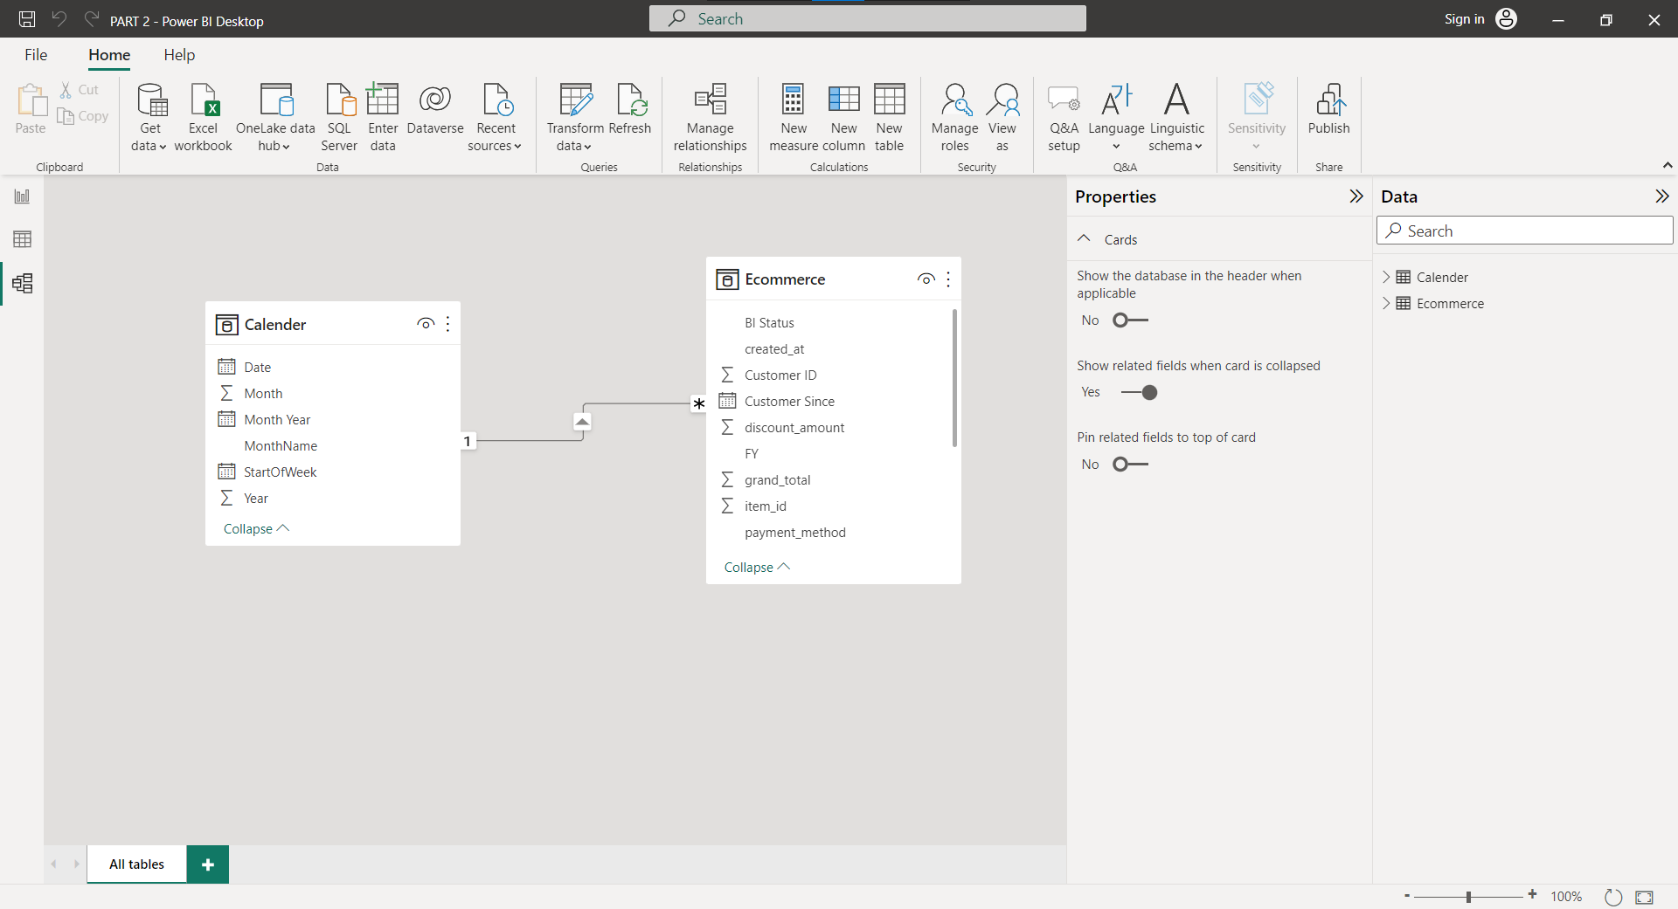

**ACTIVITY 2**

**Calculated Column**

* **Bill Type (if bill total greater than 1000, show “High” otherwise show “Normal”**

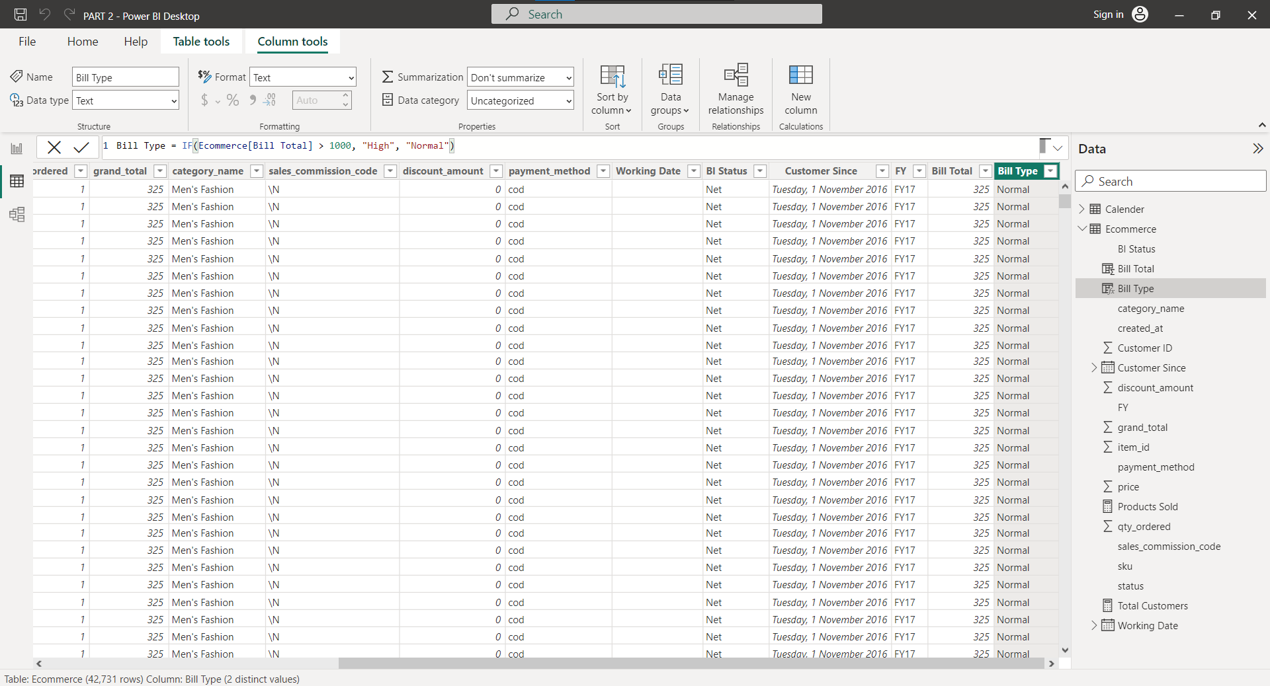

* **Bill Total (item price multiply by quantity AND then subtracted by discount amount)**

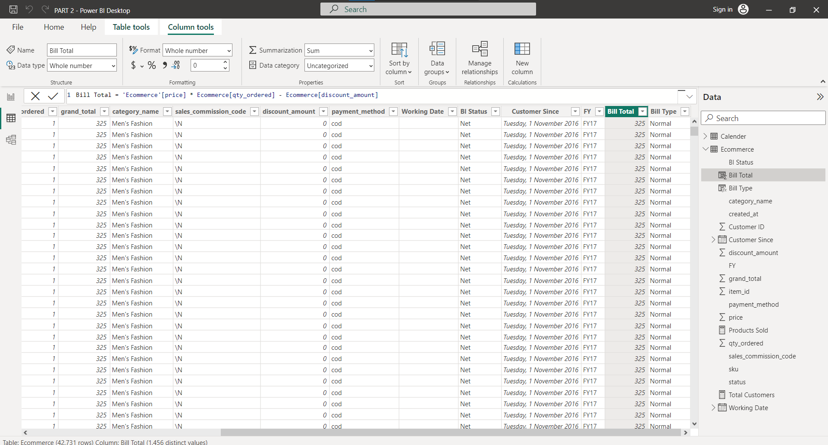

**Measure**

* **Products Sold (DISTINCT COUNT of sku)**

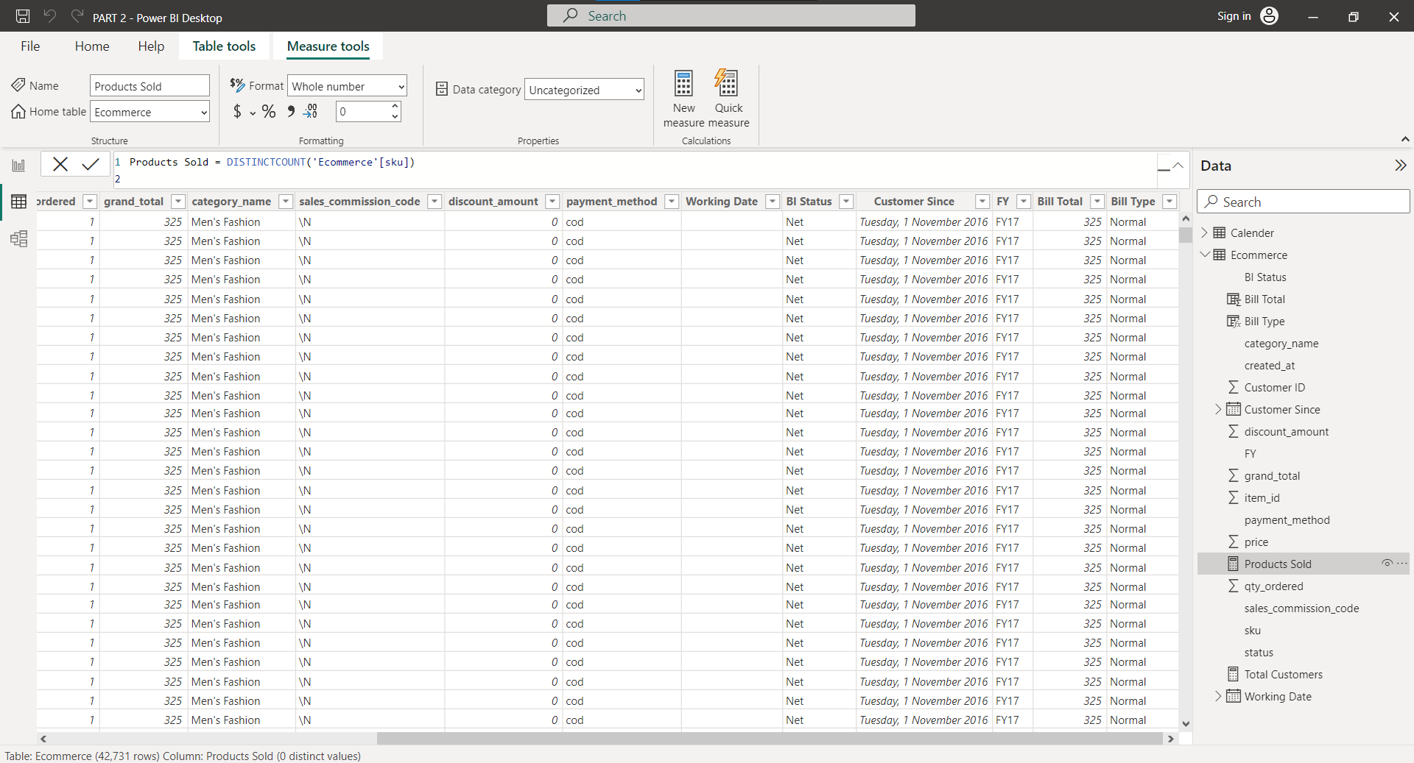

* **Total Customer (COUNTROWS of customer ID)**

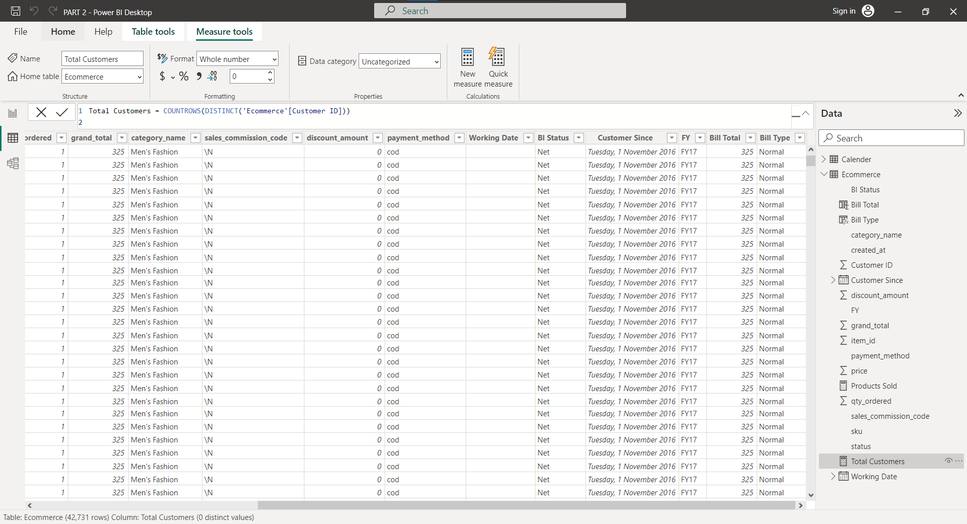

* **Total Sales (SUM of Bill Total)**

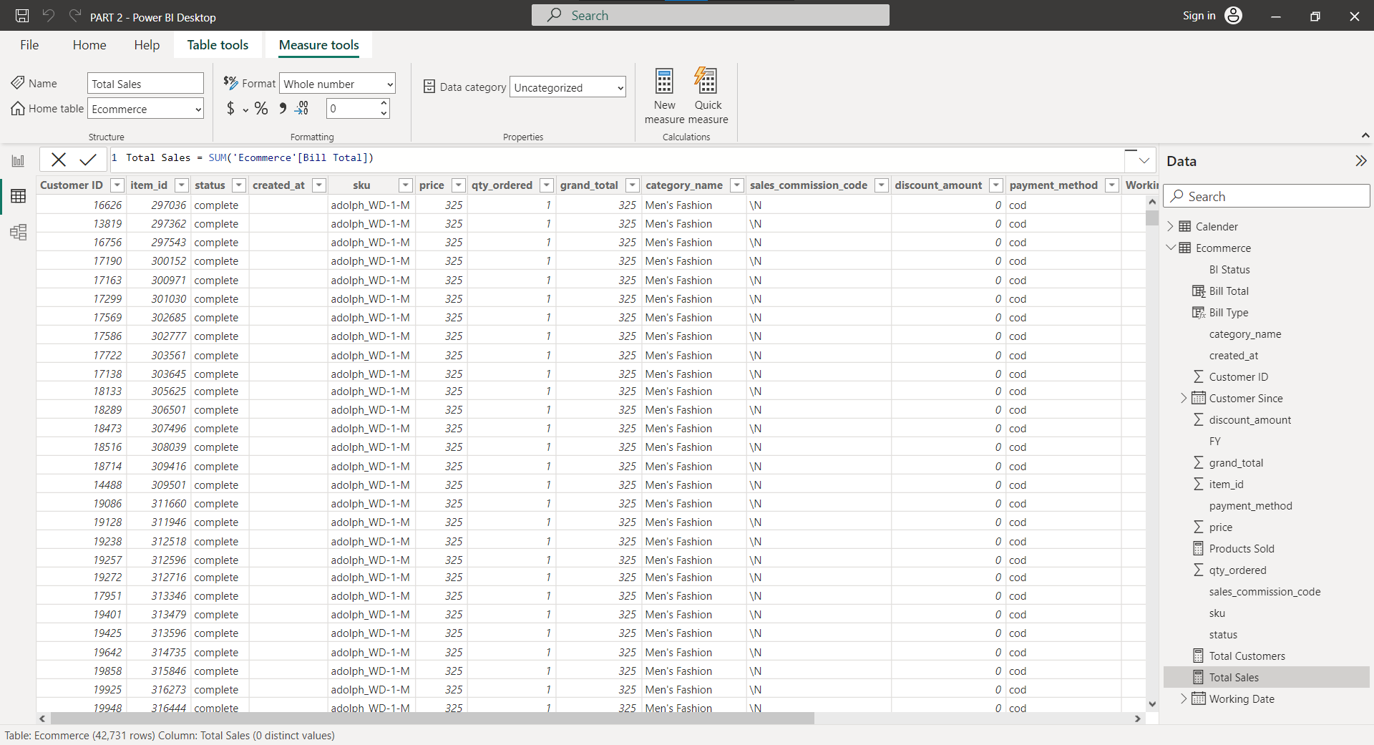

**ACTIVITY 3 (POWER BI SCREENSHOTS)**

